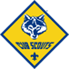
2024-2025 CUB SCOUT CALENDAR PLANNER
SEPTEMBER 2024  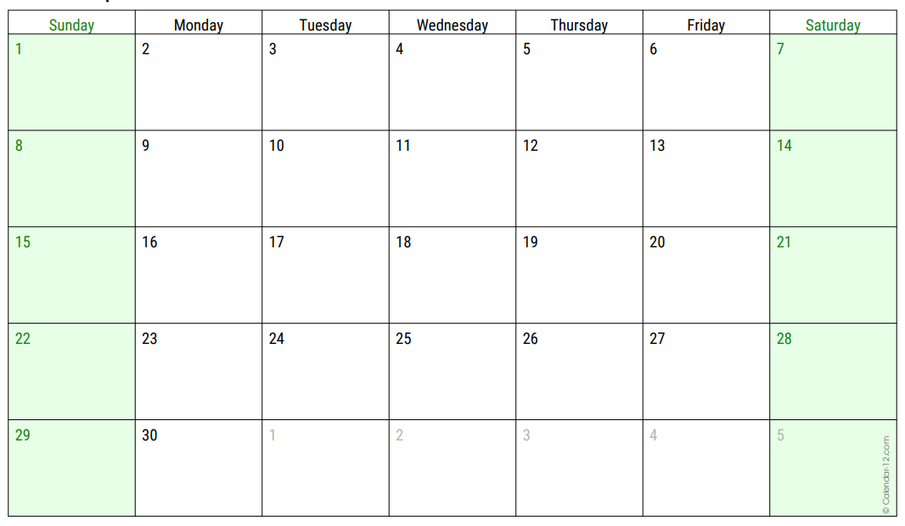 | September Pack & Den Activities  Pack Meeting (Day/Date/Time)__________________________  Pack Meeting Theme:___________________________________  _____________________________________________________  _____________________________________________________  _____________________________________________________ | Grand Canyon Council Activities  - 9/5 Roundtable - Leaders (7p.m. Zoom)  Register on Grand Canyon Council Calendar  - 9/20 to 9/22 Camp Kaibab  Greeks Greatest (Camp Raymond)  - 9/21 CS BB Open Shoot  1 p.m. to 4 p.m.; (Heard Scout Pueblo)  - 9/28 CS Archery Open Shoot  1 p.m. to 4 p.m. (Heard Scout Pueblo)
OCTOBER 2024  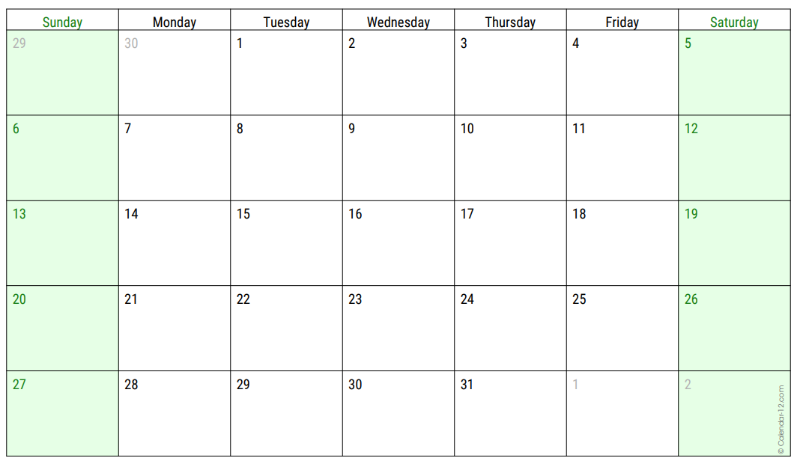 | October Pack & Den Activities  Pack Meeting (Day/Date/Time)__________________________  Pack Meeting Theme:___________________________________  _____________________________________________________  _____________________________________________________  _____________________________________________________ | Grand Canyon Council Activities  - 10/3 Roundtable - Leaders (7p.m. Zoom)  Register on Grand Canyon Council Calendar  - 10/4 to 10/6 R-Boo-C (R-C Scout Ranch)  - 10/19 CS BB Open Shoot  1 p.m. to 4 p.m.; (Heard Scout Pueblo)  - 10/28 CS Archery Open Shoot  1 p.m. to 4 p.m. (Heard Scout Pueblo)  - 10/26 to 10/27 BALOO Training (Heard)  Basic Adult Leader Outdoor Orientation  Required for Pack Family Campouts
NOVEMBER 2024  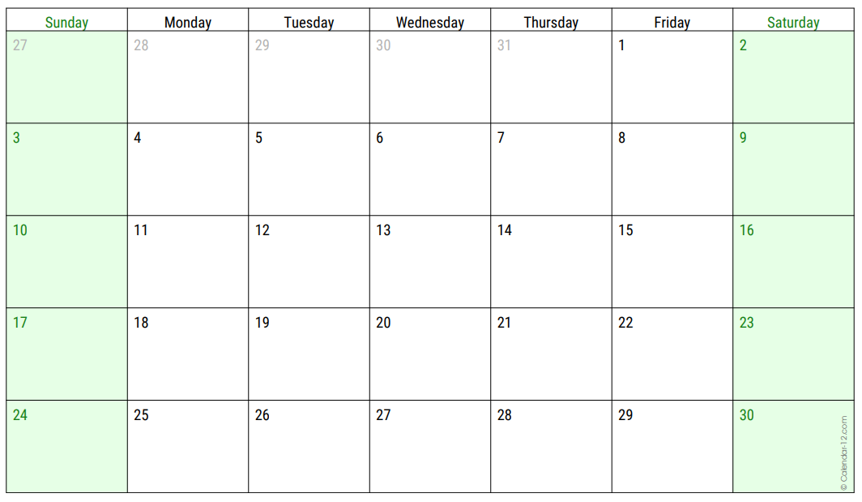 | November Pack & Den Activities  Pack Meeting (Day/Date/Time)__________________________  Pack Meeting Theme:___________________________________  _____________________________________________________  _____________________________________________________  _____________________________________________________ | Grand Canyon Council Activities  - 11/7 Roundtable - Leaders (7p.m. Zoom)  Register on Grand Canyon Council Calendar  - 11/16 Cub Scout Braves Pow Wow  (Heard Scout Pueblo)  - 11/29 Duty to God Hike  7:30 a.m. to 4 p.m. / An urban hike about 5 miles long and explores the diversity of religions in our community.
DECEMBER 2024  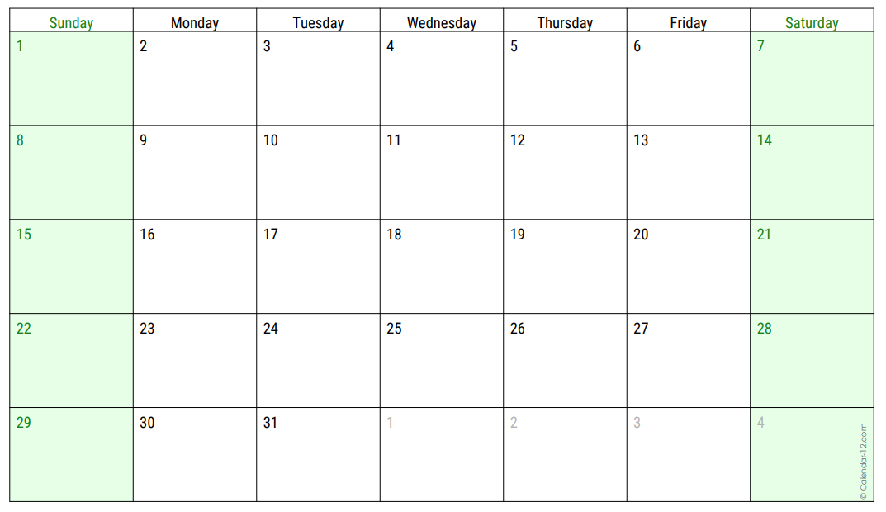 | December Pack & Den Activities  Pack Meeting (Day/Date/Time)__________________________  Pack Meeting Theme:___________________________________  _____________________________________________________  _____________________________________________________  _____________________________________________________ | Grand Canyon Council Activities  - 12/5 Roundtable - Leaders (7p.m. Zoom)  Register on Grand Canyon Council Calendar  - 12/14 CS Holiday at the Heard  (Heard Scout Pueblo)  - 12/21 CS BB Open Shoot  1 p.m. to 4 p.m.; (Heard Scout Pueblo)  - 12/28 CS Archery Open Shoot  1 p.m. to 4 p.m. (Heard Scout Pueblo)
JANUARY 2025  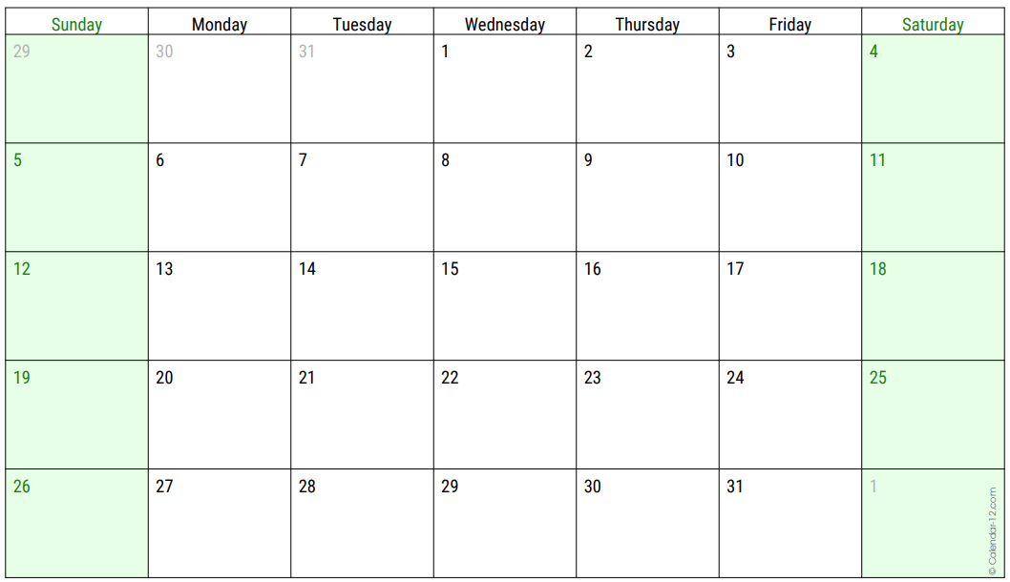 | January Pack & Den Activities  Pack Meeting (Day/Date/Time)__________________________  Pack Meeting Theme:___________________________________  _____________________________________________________  _____________________________________________________  _____________________________________________________ | Grand Canyon Council Activities  - 1/2 Roundtable - Leaders (7p.m. Zoom)  Register on Grand Canyon Council Calendar  - 1/18 CS BB Open Shoot  1 p.m. to 4 p.m.; (Heard Scout Pueblo)  - 1/25 CS Archery Open Shoot  1 p.m. to 4 p.m. (Heard Scout Pueblo)
FEBRUARY 2025  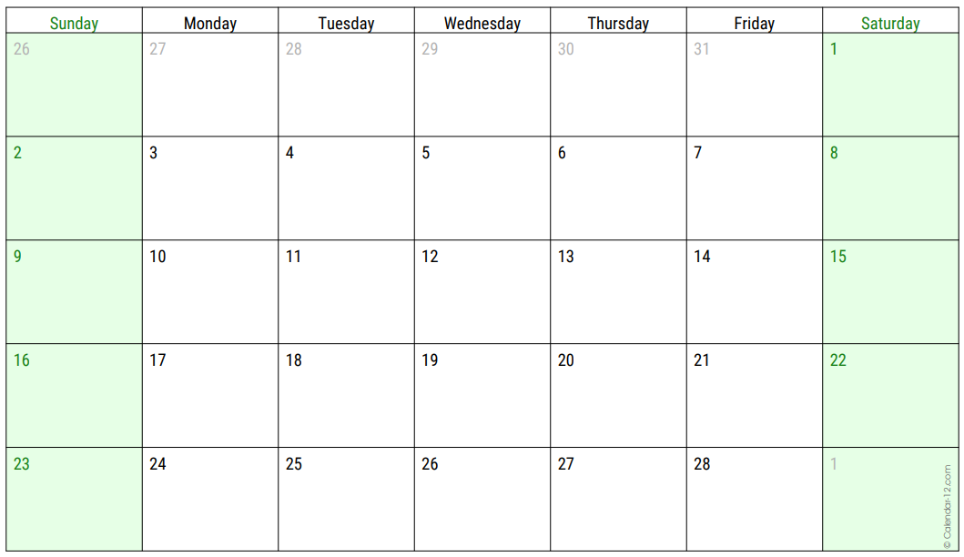 | February Pack & Den Activities  Pack Meeting (Day/Date/Time)__________________________  Pack Meeting Theme:___________________________________  _____________________________________________________  _____________________________________________________  _____________________________________________________ | Grand Canyon Council Activities  - 2/1 Scouting for Food  - 2/6 Roundtable - Leaders (7p.m. Zoom)  Register on Grand Canyon Council Calendar  - 2/15 CS BB Open Shoot  1 p.m. to 4 p.m.; (Heard Scout Pueblo)  - 2/23 CS Archery Open Shoot  1 p.m. to 4 p.m. (Heard Scout Pueblo)  - 2/22 to 2/23 BALOO Training (Heard)  Basic Adult Leader Outdoor Orientation  Required for Pack Family Campouts

2024-2025 CUB SCOUT CALENDAR PLANNER
MARCH 2025  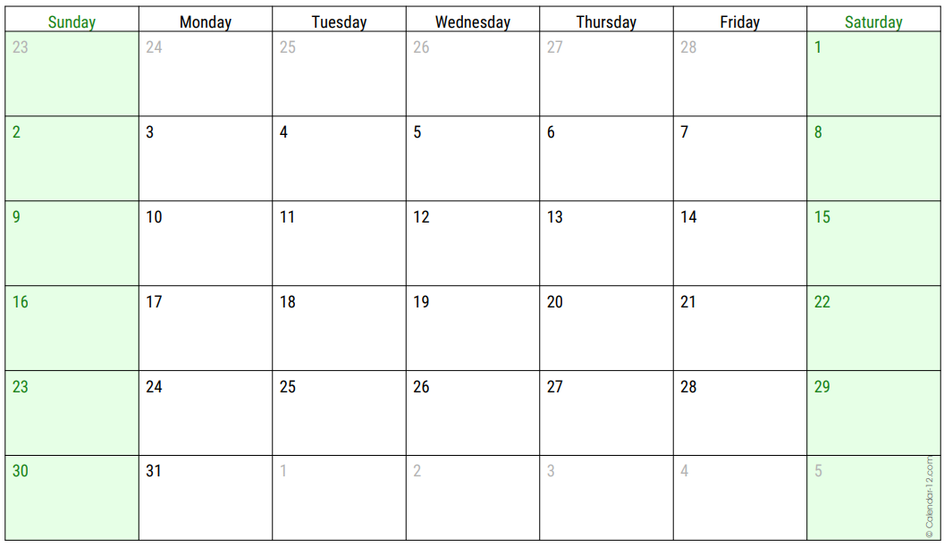 | March Pack & Den Activities  Pack Meeting (Day/Date/Time)__________________________  Pack Meeting Theme:___________________________________  _____________________________________________________  _____________________________________________________  _____________________________________________________ | Grand Canyon Council Activities  - 3/6 Roundtable - Leaders (7p.m. Zoom)  Register on Grand Canyon Council Calendar  - 3/15 CS BB Open Shoot  1 p.m. to 4 p.m.; (Heard Scout Pueblo)  - 3/22 CS Archery Open Shoot  1 p.m. to 4 p.m. (Heard Scout Pueblo)  - 3/29 CS Arrow of Light Crossover  (Heard Scout Pueblo)
APRIL 2025  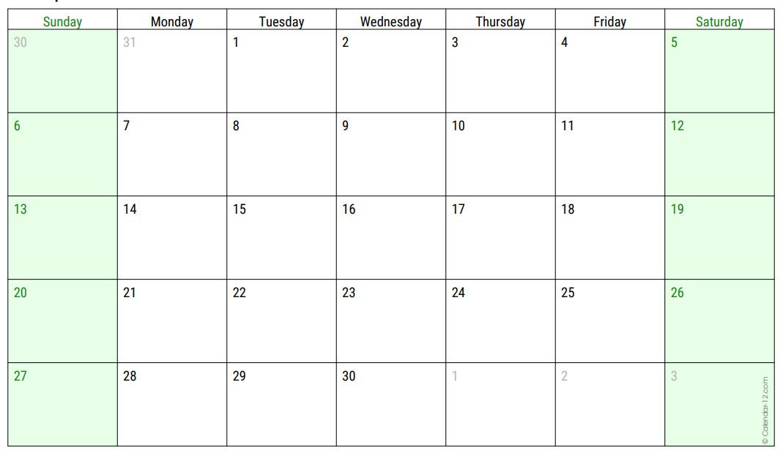 | April Pack & Den Activities  Pack Meeting (Day/Date/Time)__________________________  Pack Meeting Theme:___________________________________  _____________________________________________________  _____________________________________________________  _____________________________________________________ | Grand Canyon Council Activities  - 4/3 Roundtable - Leaders (7p.m. Zoom)  Register on Grand Canyon Council Calendar  - 4/19 CS BB Open Shoot  1 p.m. to 4 p.m.; (Heard Scout Pueblo)  - 4/26 CS Archery Open Shoot  1 p.m. to 4 p.m. (Heard Scout Pueblo)
MAY 2025  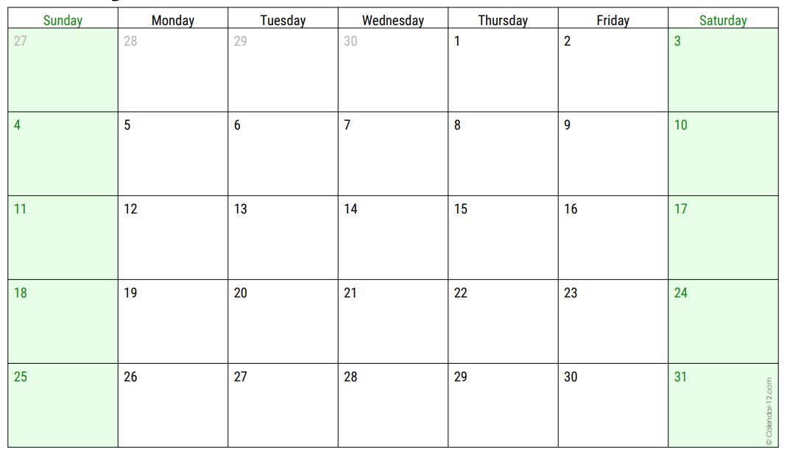 | May Pack & Den Activities  Pack Meeting (Day/Date/Time)__________________________  Pack Meeting Theme:___________________________________  _____________________________________________________  _____________________________________________________  _____________________________________________________ | Grand Canyon Council Activities  - 5/1 Roundtable - Leaders (7p.m. Zoom)  Register on Grand Canyon Council Calendar  - 5/17 CS BB Open Shoot  1 p.m. to 4 p.m.; (Heard Scout Pueblo)  - 5/24 CS Archery Open Shoot  1 p.m. to 4 p.m. (Heard Scout Pueblo)
JUNE 2025  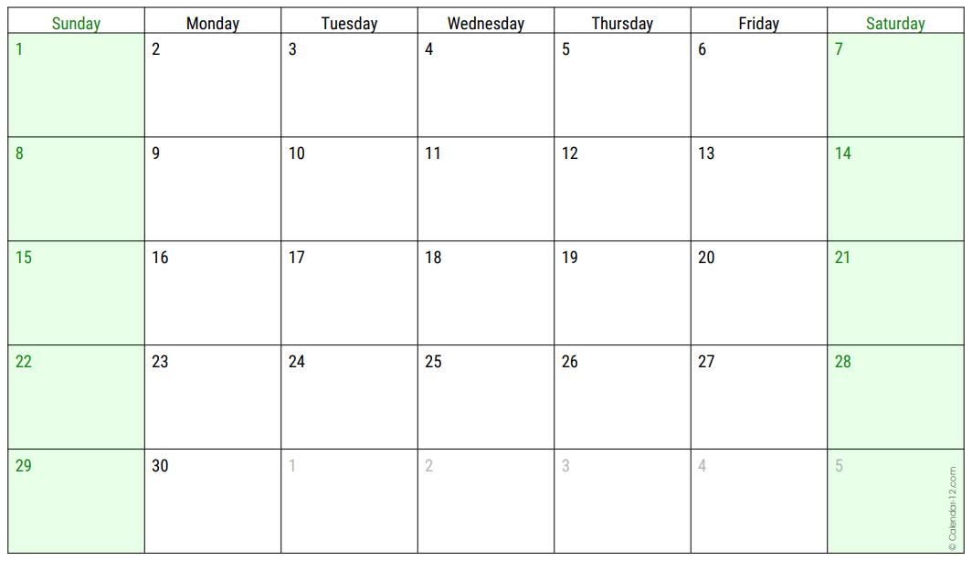 | June Pack & Den Summer Activities  _____________________________________________________  _____________________________________________________  _____________________________________________________  _____________________________________________________  _____________________________________________________ | Grand Canyon Council  Summer Activities  Cub Scout  Summer Camps  Details Coming Soon
JULY 2025  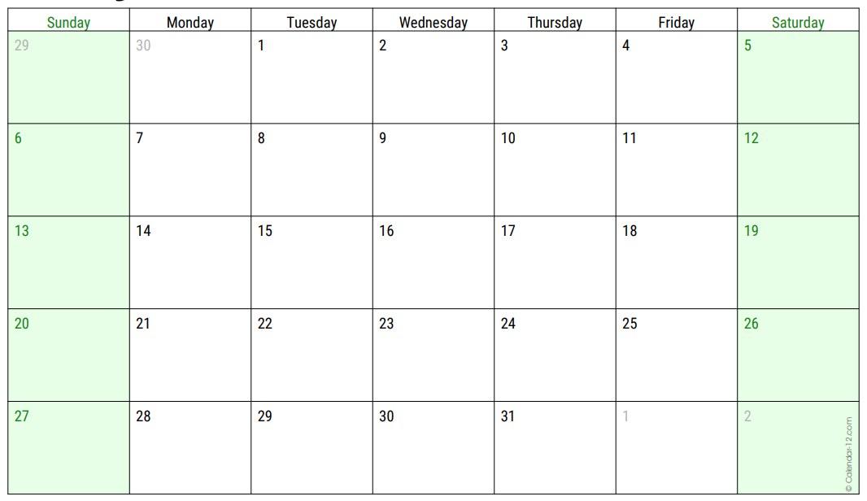 | July Pack & Den Summer Activities  _____________________________________________________  _____________________________________________________  _____________________________________________________  _____________________________________________________  _____________________________________________________ | Grand Canyon Council Activities
AUGUST 2025  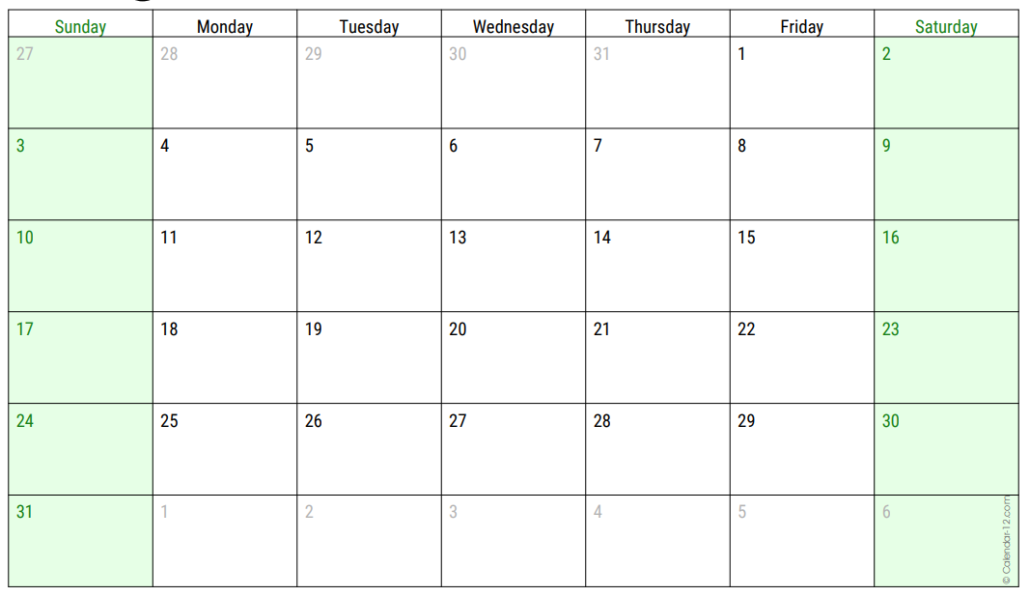 | August Pack & Den Activities  Pack Meeting (Day/Date/Time)__________________________  Pack Meeting Theme:___________________________________  _____________________________________________________  _____________________________________________________  _____________________________________________________ | Grand Canyon Council Activities  - 8/23 CS Archery Open Shoot  1 p.m. to 4 p.m. (Heard Scout Pueblo)

