**Department of Pinewood Vehicles**

**VEHICLE INSPECTION & REGISTRATION FORMS**

|  |  |
| --- | --- |
| **Racer:** | **Circle one: Lion / Tiger / Wolf / Bear / Webelos / AOL / Open / Outlaw** |
| **Pack:** | **Car Number:** |
| **Racer Signature:** | |

|  |
| --- |
| **INSPECTION REPORT:**  **PASS FAIL** |

|  |  |
| --- | --- |
|  | **Maximum Overall Width: 2 ¾”** |
|  | **Maximum Length: 7”** |
|  | **Maximum Height: Not to exceed 4”** |
|  | **Minimum Track Clearance: ⅜”** |
|  | **The front of the car does not extend beyond the starting point** |
|  | **Official BSA Pinewood Derby Kit: finished car was not purchased. (Except Outlaw Class Derby Cars)** |
|  | **Springs/Starting Devices: The car is free rolling** |
|  | **Wheels & Axles:**   * **Official BSA wheels are being used. (Except Outlaw Class)** * **All 4 wheels touch track at all times.** * **Use precut axle slots** * **Wheels are free from alteration** |
|  | **Lubrication: No liquid lubricants are used** |
|  | **Parts Securely Attached: all parts are securely attached to the car** |
|  | **Maximum Weight: car is not to exceed 5.00 ounces**  **Weight of car:_____________________** |
|  | **Car Numbering: Car Number is assigned and attached to bottom** |

**Inspected by:________________________ Date:______________**

Cub Scout Pinewood Derby

There are no national [Pinewood Derby](https://scoutlife.org/pinewood-derby/) rules, so packs are free to set their own. However, if your local council hosts a derby and you want to send your pack’s winners, you’ll need to follow their official rules on car length, width, weight and wheel construction.

Race rules are a good idea because they simplify inspections, eliminate as much confusion as possible, provide guidance and create a fair race for everyone. Make sure you know what your pack’s rules are before you start building. But remember, **the most important rule is to have fun.**

The following rules are included in every Pinewood Derby kit. They are not actually “official,” but many packs use them as the basis for their own race rules.

**CAR SPECIFICATIONS:**

* Width — 2 3/4″
* Length — 7″
* Weight — Not over 5 ounces
* Width between wheels — 1 3/4″
* Bottom clearance between car and track — 3/8″

**RULES:**

* Wheel bearings, washers and bushings are prohibited.
* The car shall not ride on springs.
* Only official Cub Scout Grand Prix Pinewood Derby wheels and axles are permitted.
* Only dry lubricant is permitted.
* Details, such as steering wheel and driver are permissible as long as these details do not exceed the maximum length, width and weight specifications.
* The care must be free-wheeling, with no starting devices.
* Each car must pass inspection, the owner will be informed of the reason for failure, and will be given time within the official weigh-in time period to make adjustment.
* After final approval, cars will not be reinspected unless the car is damaged in handling or in a race.

Remember, every pack, district and council sets its own rules for their Pinewood Derby race, so make sure you check with your local leaders to get the official rules for your race.

Optional Pinewood Derby Car Rules

Here are some additional questions that are commonly answered in a pack’s race rules.

* Must the car be built during this Pinewood Derby season? Or can racers reuse a car from previous years?
* Is it OK to use a completed car that was purchased in a store or on the Internet?
* Does your pack have a height limit for cars?
* Does it matter which materials are used to make the car? Does the chassis need to be wood, or can it be made of plastic or metal?
* Is it OK to adjust the wheelbase (the distance between the front and rear wheel)?
* Does the car need to have four wheels? Do they all have to touch the track?
* Can the car’s front end protrude beyond the starting pin?
* What adjustments are OK for the wheels? Can they be shaved, shaped or narrowed?
* Can the axles be polished? Any requirements about axle length or diameter?
* Which lubricants are permitted?

Source: Scout Life Website (https://scoutlife.org/hobbies-projects/pinewood-derby/157283/official-rules)

**Scouting**By Bryan Wendell

https://scoutingmagazine.org/2015/12/20-tips-planning-hosting-best-pinewood-derby/

**20 tips for planning and hosting the best Pinewood Derby**

**[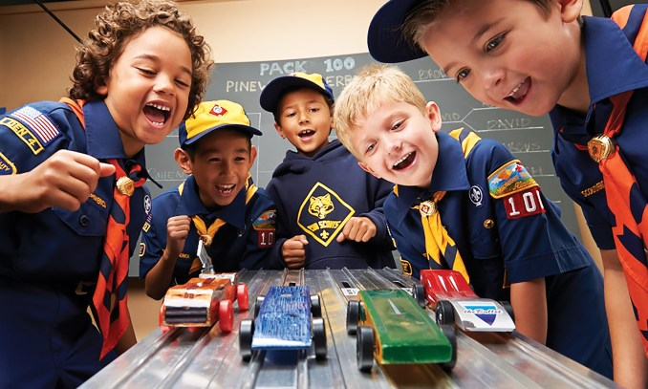](https://i0.wp.com/scoutingmagazine.org/wp-content/uploads/2016/12/PinewoodDerbyStart.jpg?ssl=1)The “why” of**[**Pinewood Derby**](https://scoutlife.org/pinewood-derby/)**needs little explanation. You do it because it’s the perfect combination of cars, competition and character-building fun. But as for the “how,” we’ve got you covered.**

***Before race day***

**1. Maintain perspective**. Pinewood Derby shouldn’t be all about racing, and it’s certainly not all about trophies or ribbons. It’s really about “the close parent-child bonding that takes place throughout the process of designing and building a Pinewood Derby car,” says Joe Gargiulo, a unit commissioner and pack race manager in the Connecticut Yankee Council.

**2. Delegate responsibilities**. Gargiulo splits volunteers into four teams: The Track Crew handles setup, testing and racing. This team includes scorekeepers, a referee and a master of ceremonies. The Pit Crew does check-in and pre-race inspection. The Activities Crew keeps youth busy when they aren’t racing. And the Food Crew? It might have the most important job of all.

**3. Establish rules**. This isn’t NASCAR. There are no national Pinewood Derby rules, so packs are free to set their own. With that said, if your district or council hosts a derby and you want to send your pack’s winners, you’ll need to follow their rules on car length, width, weight and wheel construction. Warren Kalsow runs the Pinewood Derby for the St. Paul, Minn.-based Northern Star Council. He says rules “simplify inspections, eliminate as much confusion as possible, provide guidance and create a fair race for all the youth.”

**4. Host a car-making workshop**. A few weeks before race day, plan an evening of car-building fun. Bring power tools (adults only) for the big cuts and handheld instruments for smaller refinements. Make it a come-and-go affair — 5 to 9 p.m., perhaps — where families show up for an hour or two and leave with a car that’s 80 percent ready, lacking only paint. Bring the official pack scale.

**5. Hold an inspection event**. With more than 100 Scouts, Pack 1576 in Sterling, Va., once had a Pinewood Derby that lasted until 10 p.m. After hours of check-in, inspection and races, everyone was “showing ‘E’ on the fuel indicator,” says pack trainer Zeeshan Rasheed. He found a better way: Move check-in to a few nights before the race. Cars were weighed, OK’d and then impounded in a special locked case Rasheed built himself.

**6. Gather materials**. At the first Pinewood Derby race in 1953 in Manhattan Beach, Calif., the materials list included car kits for each Cub Scout; a two-lane, 31-foot track; a battery-powered finish gate with red and white lights to show which car won; and trophies donated by a local aerospace manufacturer. Sixty-four years later? Same list, though timing technology has improved and most packs prefer a four-lane track.

**7. Establish a timing system**. Would you want to be the parent who decides which car won a close race using your naked eye? Didn’t think so. That’s why Derek Hart, now Scoutmaster of Troop 476 of Cincinnati, took away the human element in favor of a more accurate system. “We moved from an elimination bracket series judged by reluctant parents to an electronic timer system with race management software,” he says. It can be pricey, but investing in a similar system will result in better race-day operations.

**8. Use racing software**. A Google search for “Pinewood Derby software” results in several paid — and free — solutions for scheduling software that gives every car a turn down each lane. Winners are determined by a total time of all four runs — eliminating lane variations as a factor. “The software also grouped cars in subsequent heats by time, so the races all ran pretty closely,” Hart says. “Even slower cars looked pretty competitive coming down the track with other slower cars.” The result was a fair and fun derby with zero Excel-induced headaches.

**9. Determine awards categories**. Recognizing the three fastest cars in each division (Tiger, Wolf, Bear, Webelos) is obvious, but the Pinewood Derby is about more than speed. Reward creativity and craftsmanship with awards like Most Colorful, Best Paint Job and Most Patriotic. But don’t go overboard. No more than 60 percent of the Scouts should leave with an award. Those who walk away empty-handed do, in fact, leave with a valuable lesson.

**10. Recruit judges**. This is a great way to involve your chartered organization. Ask your chartered organization representative to select a judging panel, and be sure families see the list of design categories well in advance.

**11. Find some Boy Scouts**. The Pinewood Derby is a uniquely Cub Scout event, but Boy Scouts can serve refreshments, keep chaos down, and lead songs and skits. A great job for den chiefs: car handling. They can place them on the track at the beginning of each heat and carry them back to the pits after.

**12. Buy (or make) awards**. Trophies are great, but they aren’t exactly free. So Hart made his own. He created medals by cutting the trunk of a Christmas tree into discs. He sanded the discs, added a coat of polyurethane and wrote the award name with a permanent marker. An eyelet and length of leather finished the medal. “They looked pretty awesome, if I do say so,” he says.

***[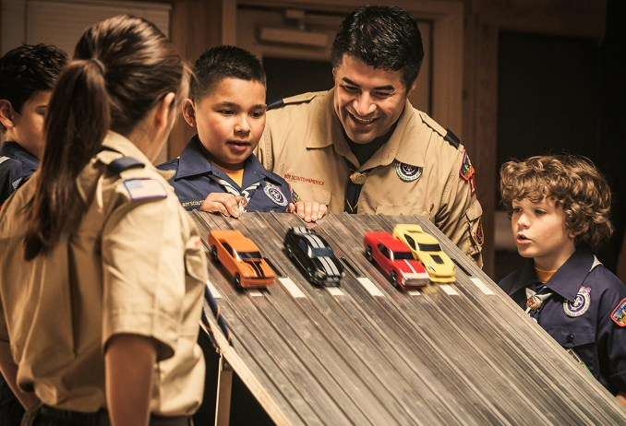](https://i0.wp.com/scoutingmagazine.org/wp-content/uploads/2016/12/PinewoodDerbyRace.jpg?ssl=1)*13. Encourage (the right amount of) parental involvement**. Some cars look like the Cub Scout got a little too much help from Mom or Dad. But the opposite is just as bad. The point is for a parent and son to bond over the shared experience. Jim Reckling, a committee member for Troop 431 of Allentown, Pa., says the amount of parental involvement should taper over time. “With Tigers, you do most of it, showing them how to safely use the tools,” he says. By his second year of Webelos, the boy does almost everything while the parent watches.

***On race day***

**14. Decorate the space**. The Pinewood Derby isn’t a regular pack meeting, and it shouldn’t look like one. Jim Brox, assistant Cubmaster of Pack 28 from Gainesville, Va., uses decorations donated by local auto shops: cardboard cutouts of NASCAR drivers, empty oil-can boxes, inflatable tires, checkered flags, replica Goodyear blimps — basically “anything that says race day,” he says.

**15. Recruit last-minute volunteers**. Count on having plenty of volunteers available for smaller tasks on race day, says Gargiulo. “Most parents would be happy to help rather than just standing around,” he says. And who knows? Your next Cubmaster could be among them.

**16. Have spare parts on hand**. A lost or broken car could ruin a Cub Scout’s experience, so Gargiulo comes prepared. “I always have extra precut cars, tools, wheels, axles and weights to give to Cub Scouts who, for whatever reason, are unable to build a car with their parent,” he says. “Make sure everyone participates.”

**17. Serve food**. A hungry Cub Scout is a grumpy Cub Scout. Hart says his pack served food (donated by local businesses) in the back of the room and used it as a fundraiser. “It managed to make a bit of money for the pack, as the derby was held over lunchtime.”

**18. Don’t be too strict**. Use rules to ensure a fair race, but don’t let them get in the way of fun. “It would devastate a child to get disqualified for things like the wheel spacing being off by a quarter inch,” Gargiulo says. Stickler for the rules? Instead of tossing the car aside, skip to the next race while the Cub Scout and his parent make a quick fix.

**19. Keep it moving**. Consider the age-old showmanship motto: Leave them wanting more. Don Whitacre, committee chairman of Pack 101 in Ann Arbor, Mich., says his pack tries to have everything done in 90 minutes. The pressure is on the master of ceremonies to “announce winners, encourage the Cub Scouts and keep the event flowing.”

**20. Watch for ultra-competitive parents**. Surprise! Parents can get a little spirited at the Pinewood Derby. Ideally, you’ve reminded them the event is for the Cub Scouts, not them. Still not enough? Tony Hooker, a Webelos den leader in Pack 173 of Concord, N.C., offers a parents’ division “with less restrictive rules to help redirect that competitive spirit,” he says. “My own entry a few years back used a model plane propeller.”