
2026-2027 CUB SCOUT CALENDAR PLANNER
SEPTEMBER 2026  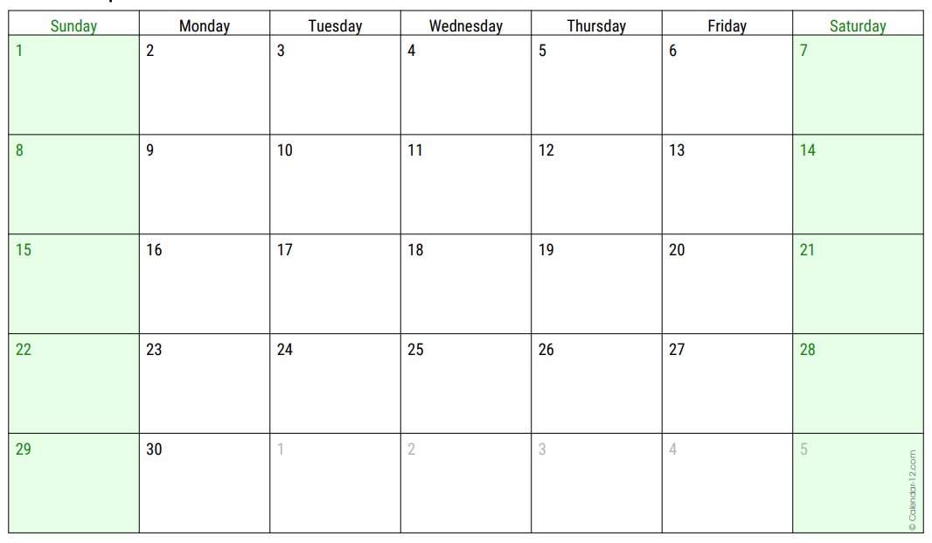 | September Pack & Den Activities  Pack Meeting (Day/Date/Time)__________________________  Pack Meeting Theme:___________________________________  _____________________________________________________  _____________________________________________________  _____________________________________________________ | Grand Canyon Council Activities  - 9/18 to 9/20 Camp Kaibab  Family Camp (Camp Raymond)  - 9/19 CS BB Open Shoot  1 p.m. to 4 p.m.; (Heard Scout Pueblo)  - 9/26 CS Archery Open Shoot  1 p.m. to 4 p.m. (Heard Scout Pueblo)
OCTOBER 2026  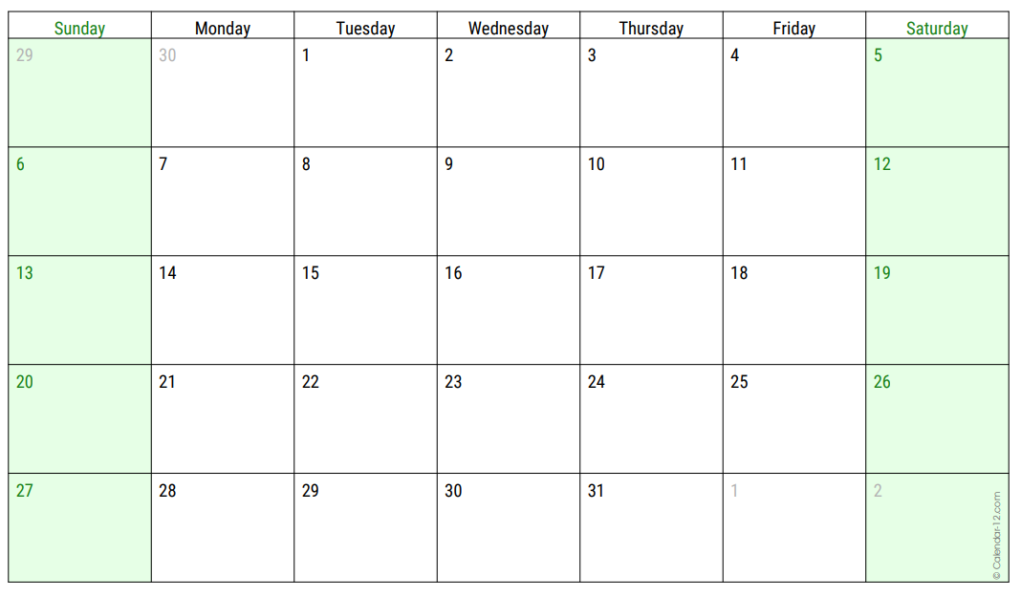 | October Pack & Den Activities  Pack Meeting (Day/Date/Time)__________________________  Pack Meeting Theme:___________________________________  _____________________________________________________  _____________________________________________________  _____________________________________________________ | Grand Canyon Council Activities  - 10/9 to 10/11 R-Boo-C Family Halloween Camp (Camp Geronimo)  - 10/17 CS BB Open Shoot  1 p.m. to 4 p.m.; (Heard Scout Pueblo)  - 10/24 CS Archery Open Shoot  1 p.m. to 4 p.m. (Heard Scout Pueblo)  - 10/24 to 10/25 BALOO Training (Heard)  Basic Adult Leader Outdoor Orientation  Required for Pack Family Campouts
NOVEMBER 2026  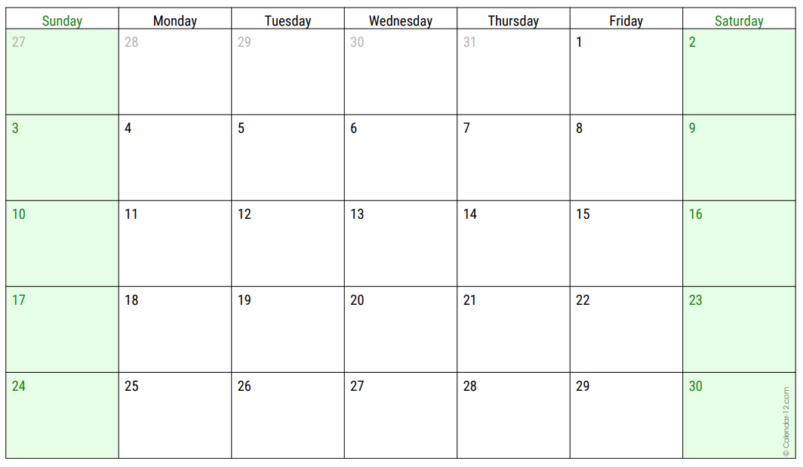 | November Pack & Den Activities  Pack Meeting (Day/Date/Time)__________________________  Pack Meeting Theme:___________________________________  _____________________________________________________  _____________________________________________________  _____________________________________________________ | Grand Canyon Council Activities  - 11/21 Cubtopia (Heard Scout Pueblo)  - 11/28 Duty to God Hike  7:30 a.m. to 4 p.m. / An urban hike about 5 miles long and explores the diversity of religions in our community.
DECEMBER 2026  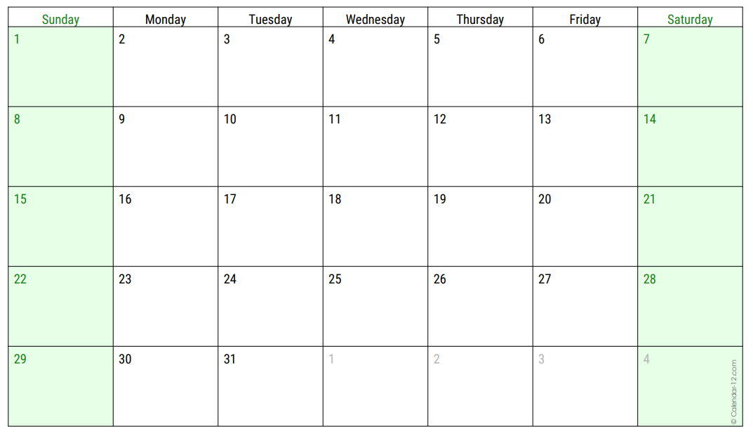 | December Pack & Den Activities  Pack Meeting (Day/Date/Time)__________________________  Pack Meeting Theme:___________________________________  _____________________________________________________  _____________________________________________________  _____________________________________________________ | Grand Canyon Council Activities  - 12/19 CS BB Open Shoot  1 p.m. to 4 p.m.; (Heard Scout Pueblo)  - 12/26 CS Archery Open Shoot  1 p.m. to 4 p.m. (Heard Scout Pueblo)
JANUARY 2027  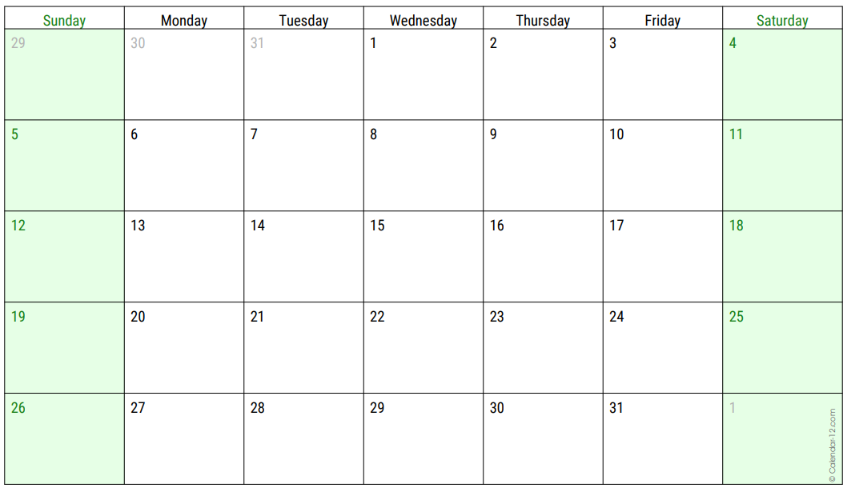 | January Pack & Den Activities  Pack Meeting (Day/Date/Time)__________________________  Pack Meeting Theme:___________________________________  _____________________________________________________  _____________________________________________________  _____________________________________________________ | Grand Canyon Council Activities  - 1/18 CS BB Open Shoot  1 p.m. to 4 p.m.; (Heard Scout Pueblo)  - 1/25 CS Archery Open Shoot  1 p.m. to 4 p.m. (Heard Scout Pueblo)
FEBRUARY 2027  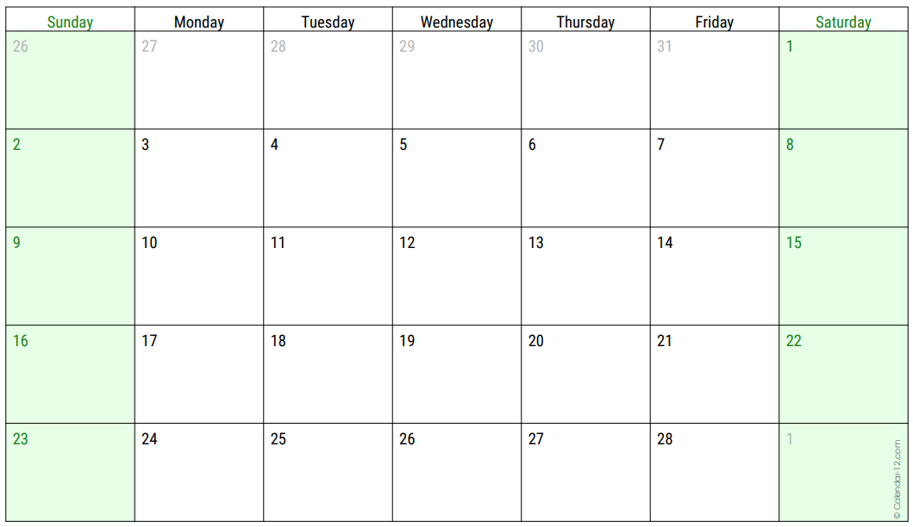 | February Pack & Den Activities  Pack Meeting (Day/Date/Time)__________________________  Pack Meeting Theme:___________________________________  _____________________________________________________  _____________________________________________________  _____________________________________________________ | Grand Canyon Council Activities  - 2/6 Scouting day of Service  - 2/20 CS BB Open Shoot  1 p.m. to 4 p.m.; (Heard Scout Pueblo)  - 2/27 CS Archery Open Shoot  1 p.m. to 4 p.m. (Heard Scout Pueblo)

2026-2027 CUB SCOUT CALENDAR PLANNER
MARCH 2027  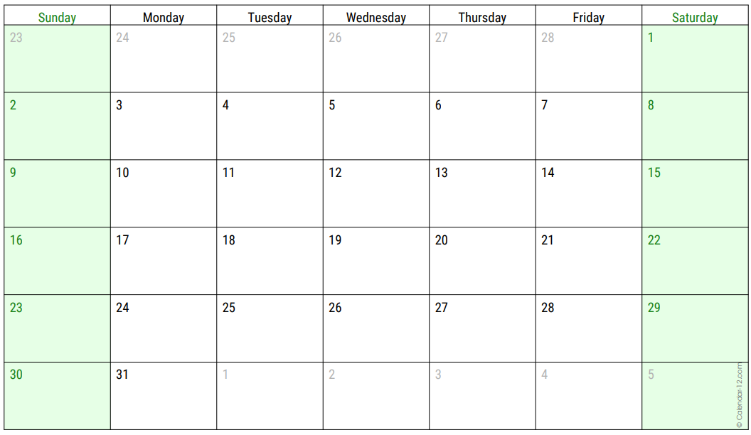 | March Pack & Den Activities  Pack Meeting (Day/Date/Time)__________________________  Pack Meeting Theme:___________________________________  _____________________________________________________  _____________________________________________________  _____________________________________________________ | Grand Canyon Council Activities  - 3/20 CS BB Open Shoot  1 p.m. to 4 p.m.; (Heard Scout Pueblo)  - 3/27 CS Archery Open Shoot  1 p.m. to 4 p.m. (Heard Scout Pueblo)
APRIL 2027  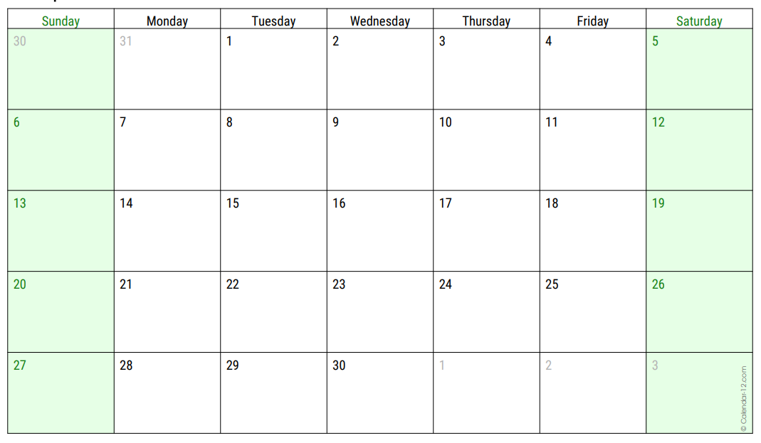 | April Pack & Den Activities  Pack Meeting (Day/Date/Time)__________________________  Pack Meeting Theme:___________________________________  _____________________________________________________  _____________________________________________________  _____________________________________________________ | Grand Canyon Council Activities  - 4/17 CS BB Open Shoot  1 p.m. to 4 p.m.; (Heard Scout Pueblo)  - 4/24 CS Archery Open Shoot  1 p.m. to 4 p.m. (Heard Scout Pueblo)
MAY 2027  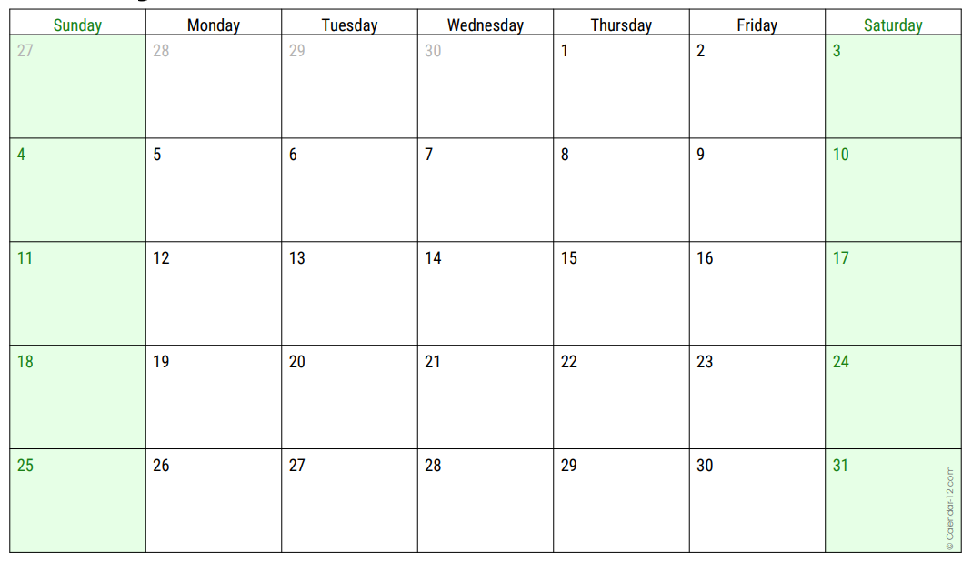 | May Pack & Den Activities  Pack Meeting (Day/Date/Time)__________________________  Pack Meeting Theme:___________________________________  _____________________________________________________  _____________________________________________________  _____________________________________________________ | Grand Canyon Council Activities  - 5/15 CS BB Open Shoot  1 p.m. to 4 p.m.; (Heard Scout Pueblo)  - 5/22 CS Archery Open Shoot  1 p.m. to 4 p.m. (Heard Scout Pueblo)
JUNE 2027  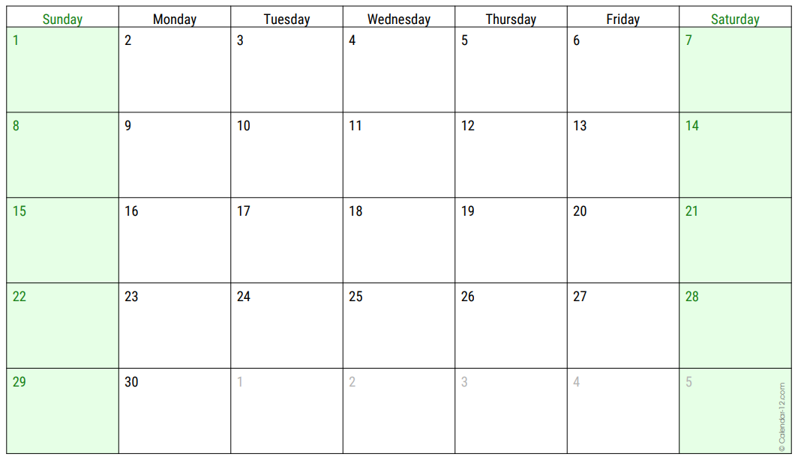 | June Pack & Den Summer Activities  _____________________________________________________  _____________________________________________________  _____________________________________________________  _____________________________________________________  _____________________________________________________ | Grand Canyon Council  Summer Activities  Cub Scout  Summer Camps  Details Coming Soon
JULY 2027  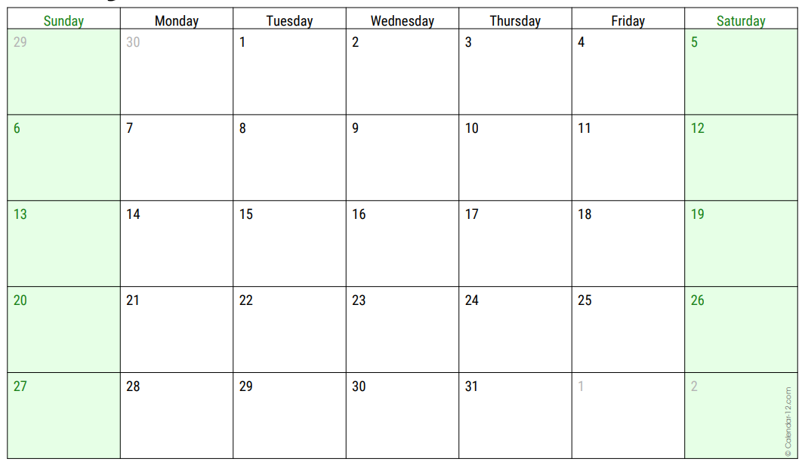 | July Pack & Den Summer Activities  _____________________________________________________  _____________________________________________________  _____________________________________________________  _____________________________________________________  _____________________________________________________ | Grand Canyon Council Activities
AUGUST 2027  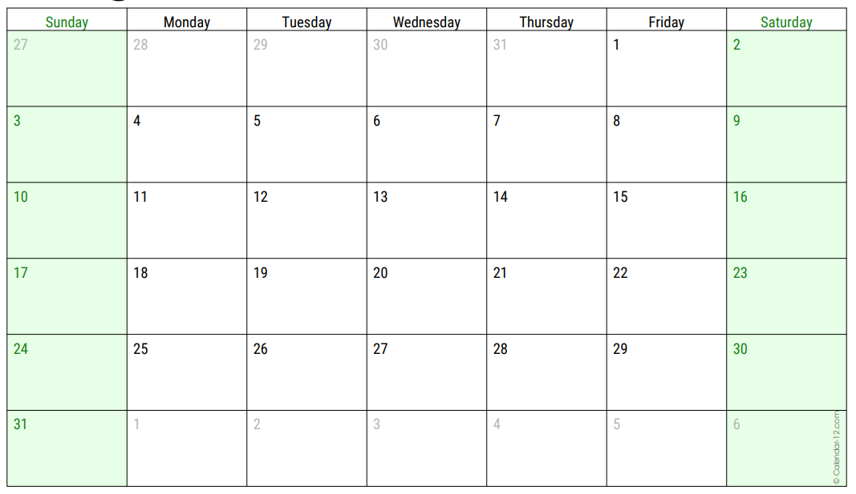 | August Pack & Den Activities  Pack Meeting (Day/Date/Time)__________________________  Pack Meeting Theme:___________________________________  _____________________________________________________  _____________________________________________________  _____________________________________________________ | Grand Canyon Council Activities  - 8/28 CS Archery Open Shoot  1 p.m. to 4 p.m. (Heard Scout Pueblo)

